I. INTRODUCTION

II. SLIPS/FALLS

III. BURNS
A. General Procedures
B. Fryer Filtering Procedures

IV. CUTS
A. Knives
B. Miscellaneous

V. LIFTING

- INTRODUCTION

INADEQUATELY TRAINED EMPLOYEES POSE THE GREATEST RISK TO RESTAURANT SAFETY. TRAINING IS A PRIMARY RESPONSIBILITY OF THE GENERAL MANAGER

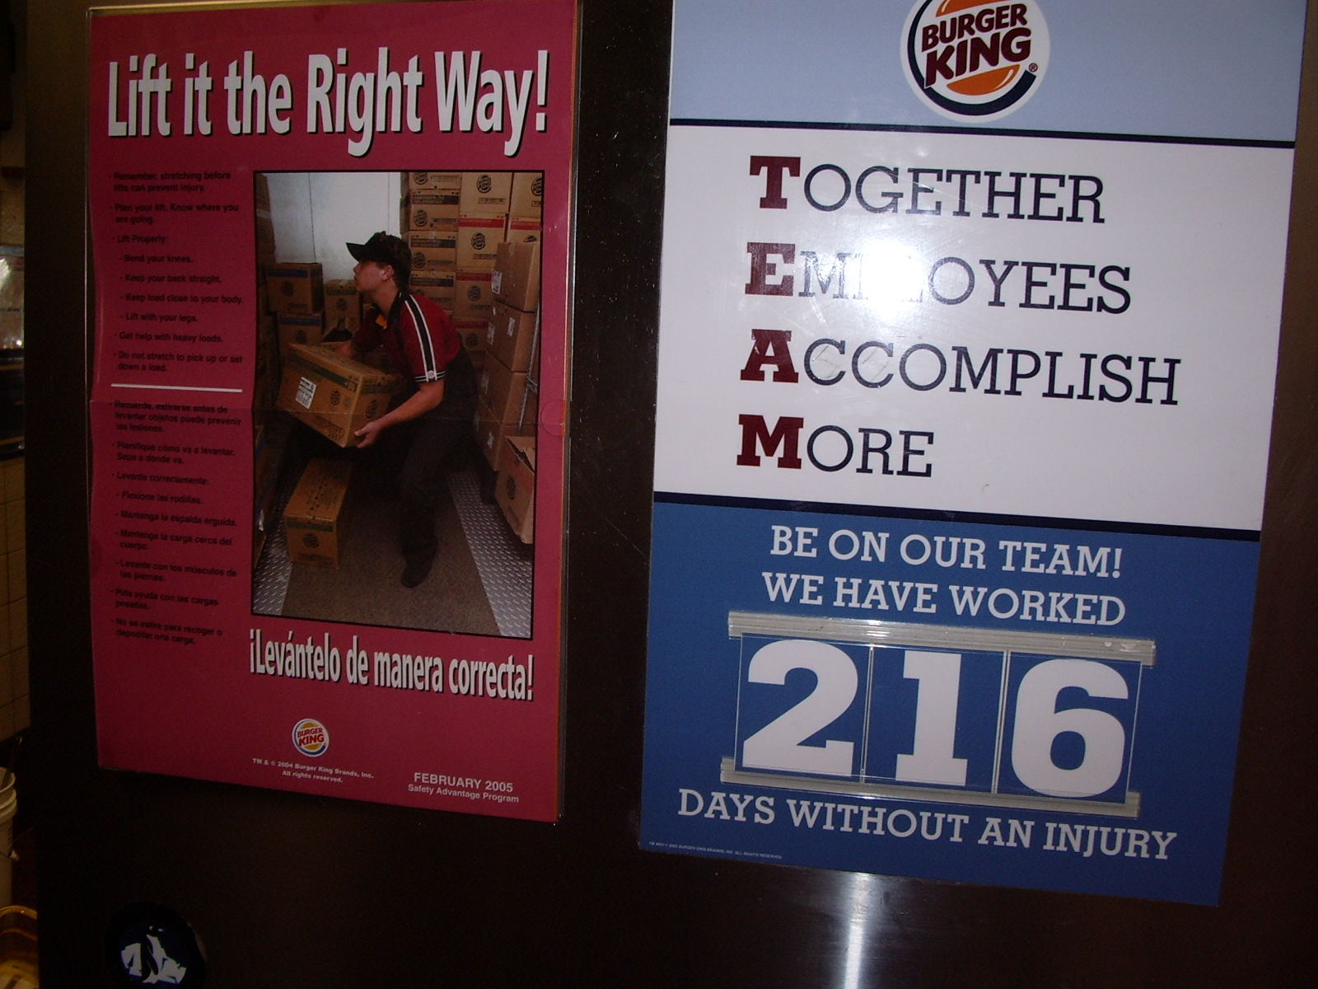
A thorough new hire safety orientation is the foundation for developing an organizations safety culture and reducing the potential for losses. Our experience demonstrates that most of our injuries are to employees with less than 6 months of employment with US Restaurants.
Each work station and employee in your restaurant pose a potential threat of an accident or injury and impact to your bottom line if safety policies and procedures are not followed. Before you can impact this area, it must be clear to all employees what the respective accountabilities and responsibilities are pertaining to crew safety.

Management Responsibilities:
- Ensure all new employees are oriented properly to our safety policy from their first day.
- Properly trained employees includes the safety aspect of their job.
- Periodic safety sensitive awarenesses are demonstratively presented to crew members..... Daily ..... Weekly ..... Monthly
- Ensure all required safety equipment is provided, maintained, and in use.
- Identification and rectification of potential unsafe acts or conditions in the restaurant.
- Periodic safety inspections as required.
- ATTITUDE - All management must positively understand that crew safety is THEIR responsibility .... demonstratively practice what they preach!

Employee Responsibilities:

- Understand their responsibility for themselves and restaurant safety.
- Follow all policies and procedures prescribed.
- Utilize equipment provided.
- Understand counseling/disciplining for not following policies/procedures.
- Report to management any perceived unsafe acts or conditions.
- Work safely at all times ..... rushing then falling does not accomplish anything!
- If not sure .... STOP ...... ASK...... DON'T ASSUME!

The policies and procedures in this section will help to prevent accidents, ensure a safe working environment for employees.
- SLIPS/FALLS

Slips and falls are the most common type of accident reported. They can result in lost work time, costly medical treatment and liability claims. Some easy to follow guidelines described below will help you to minimize the risk of slips and falls in your restaurant:

Slippery Floors
Slippery floors are the major cause of slips and falls. So, if a soda, fries or other food product spills on the floor, clean it up immediately. Be extremely cautious of grease on floors in the fryer area. When you mop up the spill, place "Caution" signs near the area to warn others that the floor is still wet.

Following proper safe work practices at the fryer will reduce grease on the floor:
  - Dumping Fried Products
    - When fried products have finished cooking, tilt the basket to drain the shortening and carry it over the other fryers to dump the product ensuring shortening and product don't spill on the floor.

Mopping
If you are mopping the kitchen or dining room floor, warn everyone working in the area to be careful. Use "Caution" signs again to ensure no one walks on the floor until it is dry. During rush periods, use a dry mop (squeeze off as much water as possible) and be extra cautious about mopping the floor.

USE COMMON SENSE. IF THE FLOOR ONLY NEEDS TO BE SWEPT, USE A BROOM, NOT A MOP.

Trips and Falls
- Don't carry loads that block your vision. - Walk - never run!
- Be careful when walking through dark areas.
- Wear only shoes with non-skid rubber
- Keep kitchen aisles clear. Dispose of empty cartons promptly.
- Eliminate stumbling hazards in the kitchen (waste cans, bun racks, etc.).

Ladder Safety
Whenever there is a need for activity above reaching level, such as changing overhead light bulbs, cleaning ceiling tiles etc., use a good sturdy OSHA approved step ladder. Do not use chair backs or table tops.
Position the ladder securely on a level surface and lock it in place.

Set it close enough to what you are reaching so you do not have to stretch. Avoid doorways and walkways since someone coming in may not see you and a serious fall may result.

Preventing Accidents on Stairs

Many of our restaurants have stairs whether between floors, leading to attics or roofs, or at receiving areas. Wherever they may be, there is potential for serious injury. These general rules apply for safety on all stairs:
- Turn on the lights.
- Make sure the stairs are clear – never use stairs for storage
- Keep your eyes on your feet.
- Get a grip on the handrail when possible.
- Watch out for spills or anything on the steps.
- If the stairs are worn or slick, immediately report the condition to your supervisor.
III. BURNS

Where do most burns in restaurants occur?
Hot frames of cooking equipment such as fryers, ranges, broilers, ovens and surfaces below heat lamps can cause burns. Horseplay and running is prohibit because it may bring you in contact with such surfaces.

- General Procedures

- Use only dry cloths, towels, mitts or pot holders when handling hot utensils.
- Use only dry mitts or pot holders when removing items from ovens.
Note: If you try to use wet mitts, the heat will transfer to your hands within seconds causing severe burns from the handles or sides of container as well as from a dropped container splashing hot food product.

If you suspect that an item MAY BE hot, assume that it is and handle it accordingly. It is much better to be safe than sorry.

- Keep oven doors closed when not in use.

- Microwave ovens build tremendous heat and steam in covered containers. Whether the cover used is plastic film wrap or lexan, be extra cautious and use gloves when removing the cover.

- The outside of the container may not be hot to the touch but the internal heat could cause scalding to the face or hands.

- When removing heavy or hot containers have adequate assistance. Know where the containers are to be placed and clear a space prior to lifting.

- Counter surfaces below heat lamps build up with heat. Provide caution signage.

- Don't clean ovens and stoves until they have cooled.

COMMUNICATE – When carrying a hot or heavy container let all others around you know. Call out “HOT” or "BEHIND YOU".

- Coffee urns and other hot beverage machines are potential sources of burns. Use proper pouring and handling techniques.

B. Fryer Area

UNLESS YOU ARE 18, STAY AWAY FROM THE FRYERS
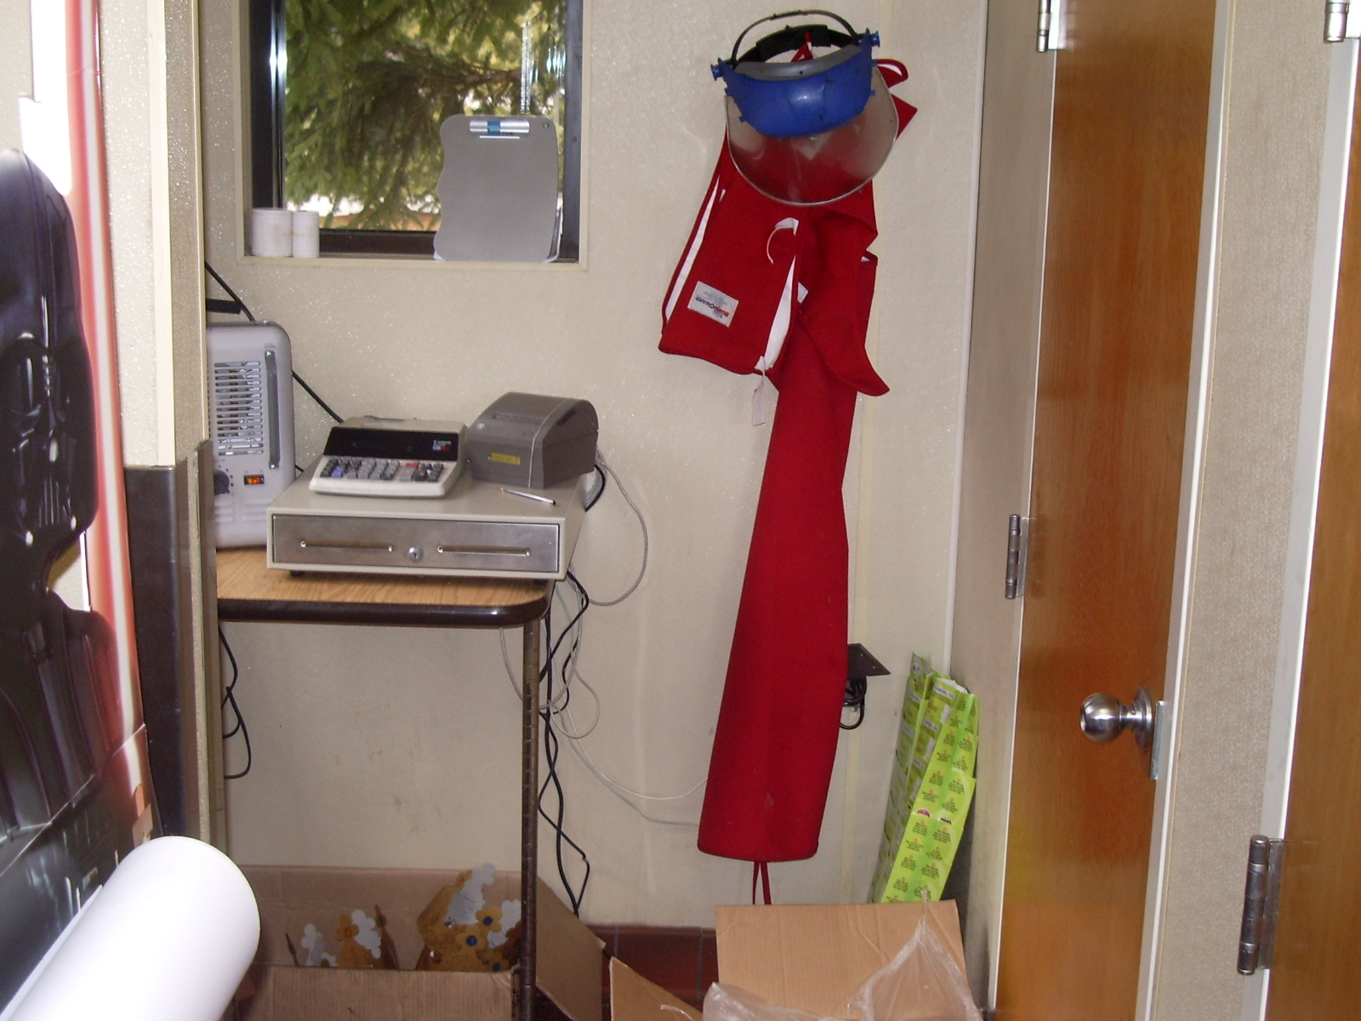
Burns occur frequently at the fry station where employees are working near hot shortening. That's why its important for you to follow the correct fry prep procedures and wear the safety equipment when they work around fryers.

The following procedures provide examples of using proper safety precautions:
1) Dumping Fried Products
When fried products have finished cooking, tilt the basket to drain the shortening and carry it over the other fryers to dump the product ensuring shortening and product don't spill on the floor. Prior to dumping french fries, alert service personnel who may be reaching in to the area by shouting “hot fries”.

2) Wet Fry Basket
Never put a wet fry basket into the shortening. When water comes into contact with hot shortening, it turns to steam and can cause the shortening to splatter.

Use tongs to remove items dropped into fryer. Many burn accidents have been reported when crew members don't think and stick their hands into hot shortening to retrieve a towel or fry skimmer.

3) Fryer Filtering Procedure
Crew members are even more susceptible to burns when they filter fryers. That's why you should be extra cautious and follow the proper filtering and safety procedures when filtering fryers.

The following procedures will help you filter fryers safely:

Units with Fryer Filtering Machines

- TURN OFF FRYER - Always turn off fryer (except pilot) and allow it to cool for at least 20 to 30 minutes.
- ALWAYS WEAR APPROVED SAFETY EQUIPMENT: rubber gloves, face shield and apron.
- SECURE HOSES - Always make sure the hoses are secured with the safety strap before operating the filtering machine. Insert the strap through the rings and snap to lock the safety strap in place.

- FILTER PRODUCT – Place one packet of filter powder in the Fryer Filtering Machines.

- POSITION MACHINE - Always position the filtering machine directly in front of the fryer and make sure the nozzle is pointed into the fry vat. (Note: Make sure bucket is free of water to avoid splattering).

- OPEN DRAIN - Slowly open drain valve to avoid splashing.

- TURN ON FILTERING MACHINE - Turn on filtering machine to clean debris from vat walls.

- CLEAN FRYER - Turn machine off, wipe down fryer walls with a cloth or towel. Make sure you are wearing protective gloves whenever you touch the inside walls or you may be burned.

- CLOSE DRAIN VALVE

- REFILL FRYER - Turn machine on and pump shortening back into the fryer. Never leave hose in fryer vat unattended. NEVER lift a bucket filled with hot shortening,

- Disconnect the Fryer Filtering Machine hose and hang it to drain excess shortening.

Poorly maintained filter equipment is frequently found to be the culprit in fryer burns.
React to maintenance issues aggressively!

UNLESS YOU ARE 18, STAY AWAY FROM THE SLICERS

- CUTS

Cuts from knives, blades on various slicers, opened can lids, and cutters and choppers are other common injuries that occur in restaurants.

To prevent cuts you must be aware of and follow procedures and safeguards when using cutting equipment or utensils. This includes the mandatory use of protective equipment such as the Whizard Glove, blade guards on slicers, and an approved knife rack.
- Knives
  - Always use the protective Whizard Glove on the hand holding the product to be sliced.

  - Do not reach blindly for a knife.

  - Never throw a knife.

  - Never try to catch a knife even if you drop it.

  - If you lay a knife down for a moment, lay it in plain sight with the blade and point away from you. A knife is not safe just because you know where it is, others may not.

  - Don't use knives as substitutes for screwdrivers, can openers, or box openers - use the proper tools.

  - Store knives only in their properly designated rack or holder. Never store knives in a drawer.

  - Don't place knives in sinks, under food or in other hidden locations.

  - Never use a knife of any kind to separate frozen food products.

  - To pass a knife to another user, place it on a flat surface and let them pick it up.

B. Miscellaneous

There are other areas where an employee may receive a cut:

- Saran Wrap or Foil Boxes. The metal edges of these boxes have caused many cuts to our employees. All users must be aware of the potential of cuts. To prevent accidents from these boxes the cutting edges should be removed entirely upon receipt of the product In this case, the film or wrap needs only to be ripped by hand.

V. LIFTING

At Burger King, lifting cases improperly is the leading cause of back injuries. A rule of thumb is to NEVER lift more than one case at a time. The extra strain caused by lifting an additional object can cause a back injury. If the case is too heavy for one person to handle, always ask someone for assistance.

Most back injuries can be avoided if crew members follow this step-by-step procedure:

- Before lifting an object, spread your feet apart at least 8” – 12” and keep your feet close to the base of the object to reduce distance and strain on your back.

- Make sure you keep your back straight and squat, bending your knees.

- Grab the object and use your leg muscles to lift it. The key is to hold the object close to your body while keeping your back straight as you lift. It allows you to use your leg muscles to lift the case not your back. Following this procedure helps to prevent back injuries.

- If you need to change directions to store the object, never twist your body. Turn your feet toward the shelf and set the case down.

I have received and read the Crew Safety information. I have also successfully completed the Crew Safety Quiz.

__________________________ ________ _________________________ _________
Employee’s Signature Date Manager’s Signature Date

